Chapter 16, Problem 51.

In the circuit of Fig. 16.74, find i(t) for t > 0.
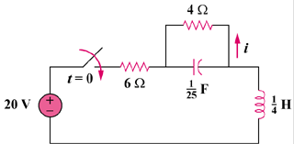
50 V

Figure 16.74
For Prob. 16.51.

